Autonomous car model

Check notation highlighted in yellow for changes from old model.

# State space formulation

Source: ME 597c lecture, Modelling III, p. 22

This will allow prediction of state variables based on control variables, forming the basis of the physics model.

See EKF formulation section for all variable definitions.

# Simulation setup

This is how the system would work in real life:

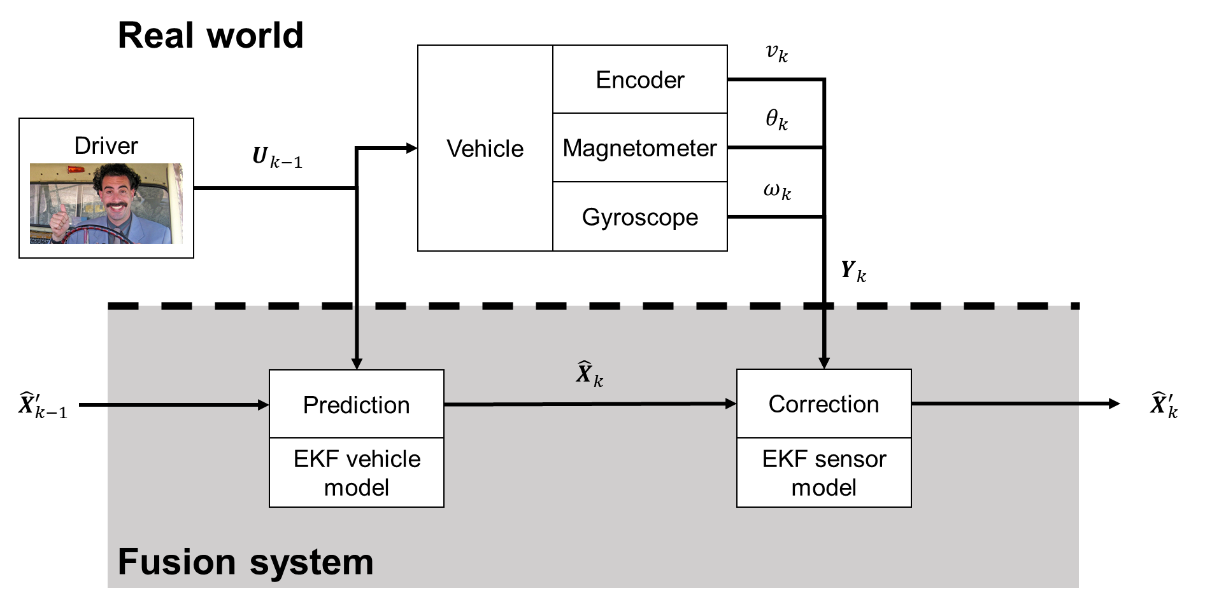

This is how we test the EKF – by replacing the real world with a high-fidelity simulation, like CARLA:

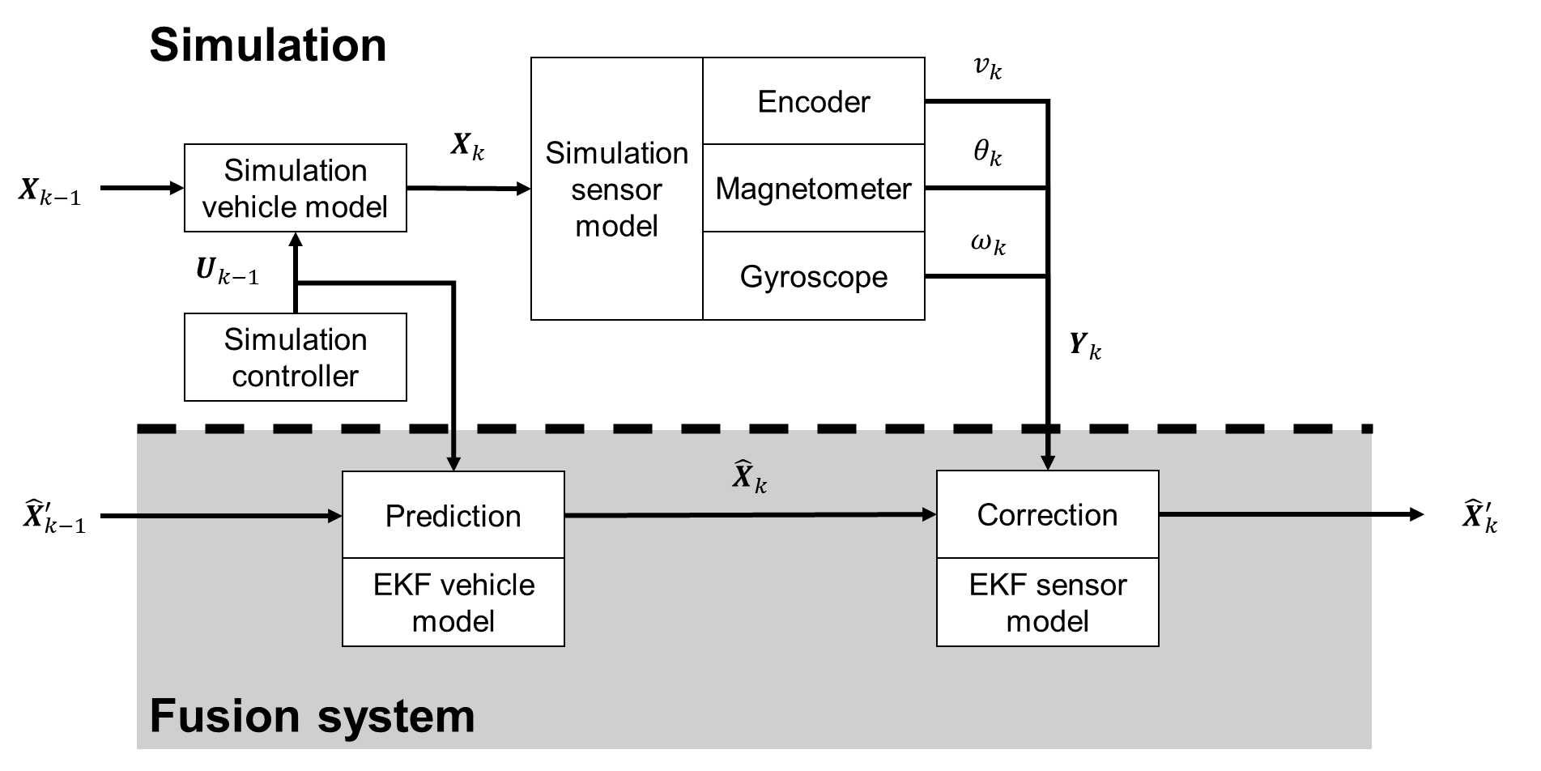

# EKF formulation

Prediction step:

Correction step:

EKF variables and functions:

: True state

: State prediction

: Corrected state prediction

: Sensor readings

: Predicted sensor readings (based on state)

: Control input vector

: Physics/state transition model (equivalent to matrix in a KF)

: Sensor model (equivalent to matrix in a KF)

: State covariance

: Jacobian of

: Jacobian of

: Physics model covariance

: Sensor model covariance

: Kalman gain matrix

Control and state variables:

: Vehicle speed [m/s]

: Yaw angle, relative to x-axis [rad]

: Yaw rate [rad/s]

: Throttle setting,

: Steering angle, (+ve = left, -ve = right) [rad]

: Steering angle rate [rad/s]

: Direction of motion for COG [rad]

: Acceleration caused by engine [m/s2]

: Deceleration caused by drag [m/s2]

Model constants – these need to be defined *a priori*, mostly by the design of the car:

: Length between rear and front wheel axes [m]

: Distance between rear wheel axis and COG [m]

: Friction coefficient [1/s]

: Specific power model parameter 1 [m/s2]

: Specific power model parameter 2 [1/s]